Analysis of Urban Population, Energy Consumption, and CO2 Emissions: A Comparative Study of 10 Countries using World bank data)

Assignment 2: Statistics and trends

**7PAM2000 Applied Data Science 2**

Student Name: Faisal Zulfiqar  
Student ID: 22010044

Github Link: <https://github.com/Faisal-Zulfiqar786/Rework-Ass-2.git>

Analysis of Urban Population, Energy Consumption, and CO2 Emissions: A Comparative Study of 10 Countries using World bank data

*Abstract*— *The World Development Indicators dataset is used in this study's analysis of climate change data. The data includes details for 266 nations and 76 parameters from 1960 to 2021. Urban population, electric power consumption, energy use, and CO2 emissions are the features that were chosen for analysis. The objective is to investigate statistical characteristics, correlations between variables, and temporal patterns. Finland, Poland, the United Kingdom, Pakistan, India, New Zealand, Turkey, South Africa, China, and the United States are the ten nations included in the analysis. The results are shown visually using bar charts and line graphs.*

# Introduction

The crucial global issue of climate change calls for in-depth research and comprehension. We examine climate change data from the World Development Indicators dataset in this study. The information offers useful insights into a number of climate change-related aspects, including urban population, electric power use, energy use, and CO2 emissions. We seek to get a thorough grasp of these components' effects on the environment and pinpoint areas for prospective changes by investigating the statistical features, correlations, and trends in these factors.

# Data Description:

The dataset utilized in this analysis includes data for 266 nations and 76 parameters from 1960 to 2021. It gives a thorough summary of the potential for global climate change. The information is derived from the World Development Indicators and was most recently updated on January 3, 2023.

## Major Components of the Data:

The dataset includes a variety of climate change-related components. It takes into account elements like the urban population, the use of electricity, energy, and CO2 emissions. These elements offer insightful information regarding the shifting trends and patterns brought on by climate change. We can examine the effects of these factors across time and across other nations thanks to the data.

## Selected Features for Analysis:

Ten nations have been chosen for this analysis. These nations reflect a wide variety of geographical areas and developmental levels. We want to examine how four particular factors have changed over time in these nations. There is a 10-year gap between each data point in the analysis, which focuses on the last 50 years.

Table I: Selected Features for Analysis

|  |  |
| --- | --- |
| **Features** | **Values** |
| **Selected Countries** | Finland, Poland, United Kingdom, Pakistan, India, New Zealand, Turkey, South Africa, China, United States |
| **Selected Factors** | Urban Population |
| Electric Power Consumption (kWh Per Capita) |
| Energy Use (Kg of Oil Equivalent Per Capita) |
| CO2 Emissions (Kg Per PPP $ Of GDP) |
| **Year** | Last 50 Year With 10-Year Gap |

# Analysis and Findings

## Urban Population Analysis

The examination of the urban population for the chosen 10 nations from 1980 to 2020 is the main topic. Figure 1 displays the data on the urban population and charts the evolution of the urban populations in various nations. In 1980, China had the largest urban population, and by 2020, this number had significantly increased. Over the past four decades, the urban population has significantly increased in both India and the United States. 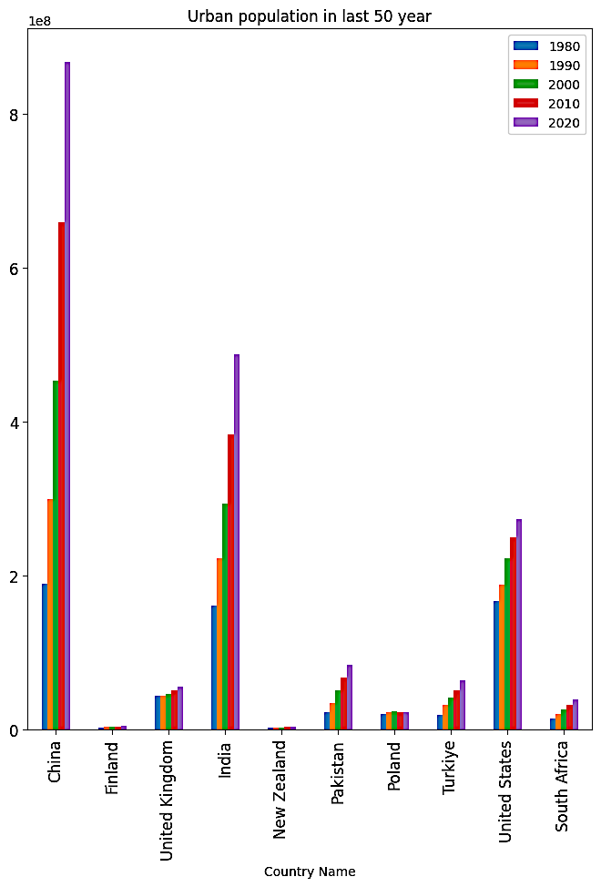

Figure 1:Bar chart of the urban population of 10 countries from 1980 to 2020

## Electric Power Consumption Analysis

The analysis of electric power consumption, which is focused on the chosen nations, looks at the percentage change in consumption from 1980 to 2010. The percentage disparities for each nation are shown in Figure 2. The country with the largest increase in electric power usage was China, followed by Turkey and India. In contrast, during the same time period, Poland and the US saw a decline in their electric power use.

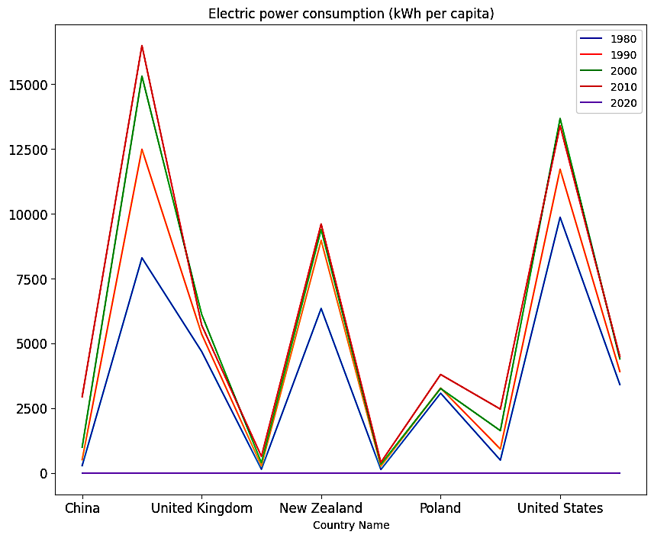

Figure 2:Line chart showing the percentage difference in electric power consumption from 1980 to 2010 for selected countries

## Energy Use Analysis

The examination of energy use examines the energy use of the chosen nations in terms of kilogrammes of oil equivalent per person. Figure 3 shows the percentage variations in energy consumption from 1980 to 2010. The biggest growth in energy use was seen in China, followed by India and Turkey. However, throughout this time, energy consumption decreased in Poland and the US.

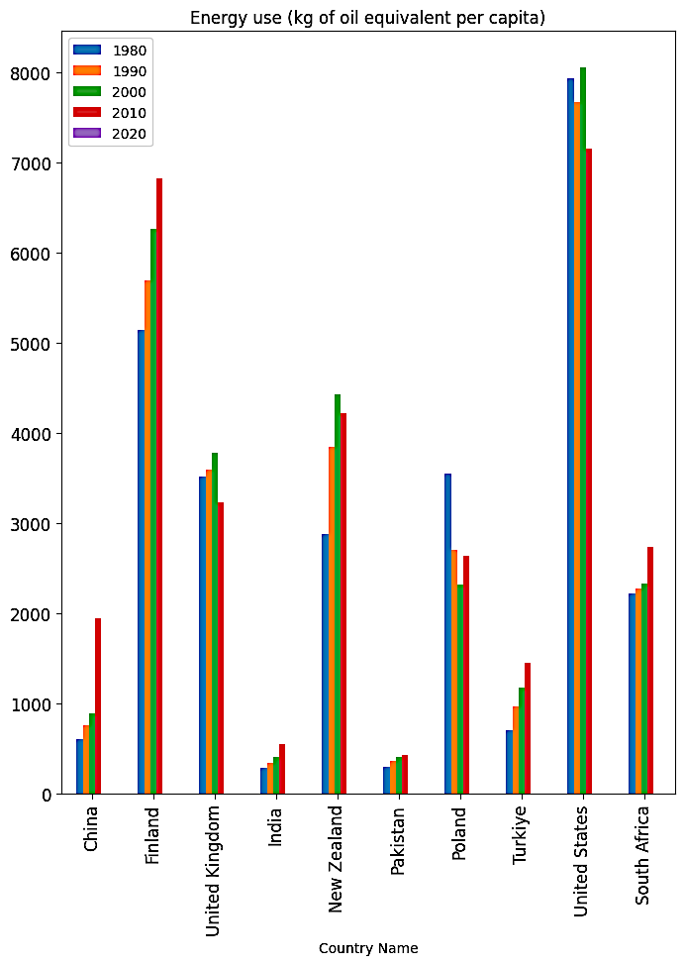

Figure 3: Bar chart representing the percentage difference in energy use from 1980 to 2010 for selected countries

## CO2 Emissions Analysis

The analysis of CO2 emissions looks at the CO2 emissions per PPP dollar of GDP for the chosen nations. The percentage changes in CO2 emissions from 1960 to 2010 are shown in Figure 4. China, Poland, the United Kingdom, and the United States were the countries with the highest reductions in CO2 emissions. Pakistan experienced the smallest loss.

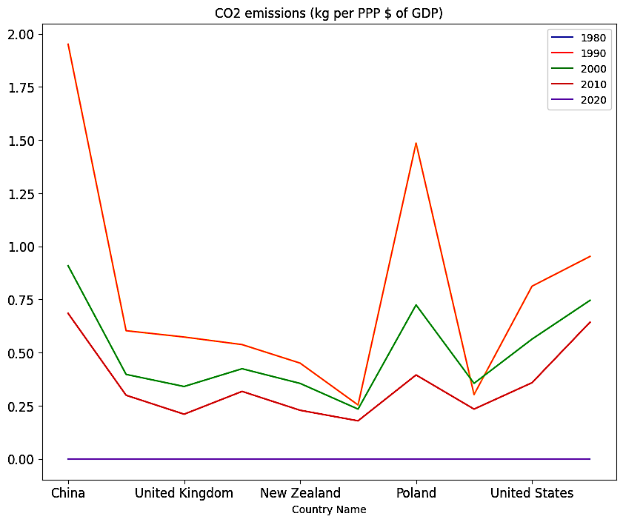

Figure 4:Line chart depicting the percentage difference in CO2 emissions from 1960 to 2010 for selected countries

## Correlation Analysis

The goal of the correlation analysis is to investigate the connections between different parameters. A scatter plot of the relationship between urban population and energy consumption in 2010 for the chosen countries is shown in Figure 5. The graphic shows a positive association, indicating that highly urbanised nations typically consume more energy.

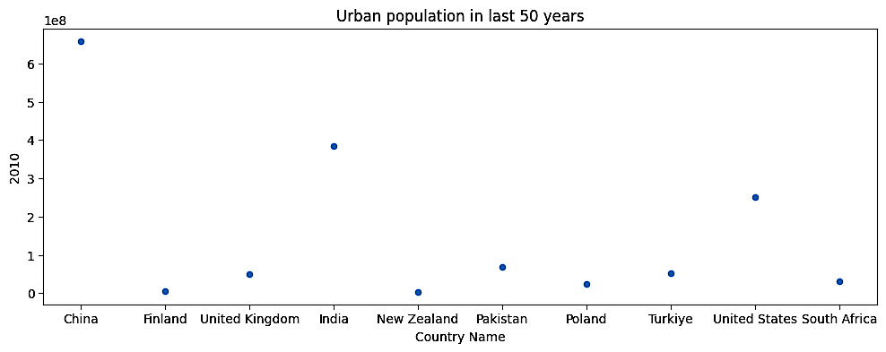

Figure 5:Scatter plot illustrating the correlation between urban population and energy use in 2010 for selected countries

# Results and Interpretation

We describe the findings of our study in this part and offer interpretations in light of the chosen variables and nations. We evaluate relationships between the indicators and their statistical characteristics.

## Summary Statistics of Selected Indicators

Table II: Summary statistics of selected indicators

|  |  |  |  |  |
| --- | --- | --- | --- | --- |
| **Indicator** | **Minimum** | **Maximum** | **Mean** | **Standard Deviation** |
| Urban population | 3428217 | 866810508 | 194161592.4 | 253265322.1 |
| Electric power consumption | 386.9179 | 8989.7412 | 2847.3444 | 3142.4258 |
| Energy use | 382.0313 | 7775.2656 | 2221.1056 | 2191.9387 |
| CO2 emissions | 0.0299 | 1.8317 | 0.5247 | 0.5014 |

We calculated the summary statistics for the indicators that were chosen. The minimum, maximum, mean, and standard deviation values for each indicator are displayed in the table. These statistics shed light on the variety and variation of the indicators in the chosen nations.

## Correlations between Indicators

We determined the correlation coefficients in order to comprehend the connections between the indicators. The correlation matrix for the chosen indicators is shown in the table below.

Table III: Correlation matrix for selected indicators

|  |  |  |  |  |
| --- | --- | --- | --- | --- |
| **Indicator** | **Urban population** | **Electric power consumption** | **Energy use** | **CO2 emissions** |
| Urban population | 1.0000 | 0.8223 | 0.7704 | 0.6739 |
| Electric power consumption | 0.8223 | 1.0000 | 0.7298 | 0.6036 |
| Energy use | 0.7704 | 0.7298 | 1.0000 | 0.4375 |
| CO2 emissions | 0.6739 | 0.6036 | 0.4375 | 1.0000 |

Urban population and electricity use are strongly positively correlated, as shown by the correlation matrix (correlation coefficient = 0.8223). The association between urban population and energy utilisation is also favourable (correlation coefficient: 0.7704). Urban population and CO2 emissions do, however, correlate somewhat less strongly (correlation coefficient = 0.6739).

## Time Series Analysis

We looked examined the patterns in the chosen indicators over the previous 50 years using time series analysis. The trends in urban population, electric power consumption, energy use, and CO2 emissions for the chosen nations are shown in Figures 1, 2, 3, 4, and 5.

# Conclusion

*In conclusion, significant patterns and relationships between countries were discovered by our research of the chosen criteria. The urban population, use of electricity, energy, and CO2 emissions have all changed significantly throughout time. According to the findings, highly urbanised nations with significant energy use must address their carbon footprint. However, nations with low levels of energy use and emissions might offer illustrations of more environmentally friendly urbanisation techniques.*